Web 0 put website online without 1$

1.

First session: IP address -fixe IP – CMD (IP config) – IIS – web server= pc + IP fixe+ IIS (in windows)

Your knowledge in node JS you’ll be able to make a software that runs with fixe IP machine (server). It makes that a web server.

Run in the browser

JS interacts with the

DOM

JS DOM

Run JS outside the browser

Put html 5 file on a fixe server and put node.js code in another server

Node JS run fast than Microsoft because it use V8 software (2012)

Node.js: run js out the browser => you can run it without HTML =>

NPM: node package manager

Interface: app when you use

**Node JS** is a CLI (command line interface)

CMD is the only place when you can run **node JS**

It just run **JS**

**Node JS** can not **determine** element of JS who interacts with DOM ( get.ElementByID / alert ..)

**Node JS** ⬄ npm: for use npm it should was a package has extension .**json**

Go to CMD

Node package manager text here

init

Ping UR 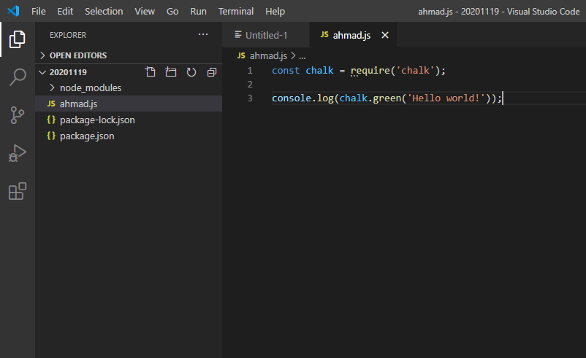

Package when the js code is writing

For make sure the patient use your same virsion of packege

It is create by cmd>npm init

For استرداد file node

cmd

Ip config

Ping www….

Cls

Code .

Node index.js

Npm I -g nodemon ( عمله مراقبة الفايلات الموجودة معه )

IIP

json

Json: java script object notation (easy Way to represent data)

Example of json data

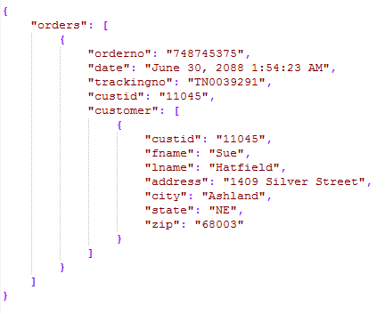

When the API arrived applie the code

js

Alert(‘’)

Document.getElementById(‘’).innertHTML=…/src

If(…){….}else{}

fetch('https://restcountries.eu/rest/v2/all')

.then(response => response.json())

.then(json =>{

     for(let i = 0; i < json.length; i++){

var x = document.createElement('img')

x.src= json[i].flag;

document.getElementById('ahmad').appendChild(x)

}

})

API= application programing interface (black box you use without know its content).

Web API= API leaves on the web we don’t need to have a local copy

بدل تنزيل ملف module and json.lock يستعمل فقط ال URL الخاص به لربطه بالمعلومات.

|  |  |
| --- | --- |
| Local package | Global package |
| Install in the folder when I am in only | Install in all the desktop  (same a software in your pc) |

Not all the package can install (global) ; when you install a package global it same one pieces of the windows (ex: nodemon)

Postman for check in the API

http verb: get- post…

session 20201128

عمل localhost و حط بديل res.innert res.json اجا بدو يعيطلا بفيتش من ملف HTML عطيت error اسمو CORS

**CORS: Cross Origin Resource Sharing.**

**There was a code in NPM, his name is cors. Will be te relation in the top enable**

1. **Git init**
2. **https://www.freecodecamp.org/news/how-to-deploy-your-site-using-express-and-heroku/**

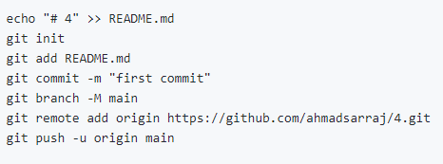

For open your account in github

For push it in github

That Is the last update

Create a file unvisible

**TS/JS**

OOP: Object Oriented programing.

This is a smart way to develop your code to avoid repetition and to make your code adaptable

Microsoft makes TS language wish the browser and the node.js don’t understand it. That language will be translated to ecmascript when node.js and the browser understand it.

It makes a package his called typescript (globale)\



**1.**



**2.**



Compiler typescript

Class is a collection of property:

class person {

    name : string;

    age : number;

    registrtion : Date;

let x = new person(); // x called object / instance

 x.name = "ahmad";

 x.age = 55;

 x.printmyname();

 let y = new person();

 y.name = "omar";

 y.age = 80;

 y.printmyname();

extends relate one class to another class:

class student extends person{

    schoolID : number;

}

constructor()

is a function when you typing it on the class it run without you called it

constructor(){

this.registrtion = new Date();

   console.log("ana l constructor")

   console.log(this.registrtion);

    }

export class person {

    name : string;

    age : number;

    registrtion : Date;

    printmyname(){

        console.log(this.age);

    }

    constructor(){

this.registrtion = new Date();

   console.log("ana l constructor")

   console.log(this.registrtion);

    }

}

export interface inotifier{

    sendsms();//not emplimented;

}

interface class

type function not implimented type function implimented

export interface inotifier { export class inotifier {

sendsms();//not emplimented;} sendsms(){prompt(‘ there are polution’)}}

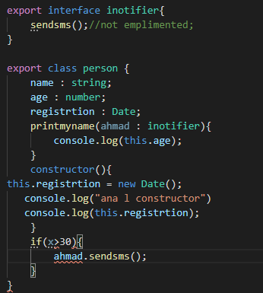

Ahmad = inotifier

Inotifier -> sendsms

=>

ahmad -> sendsms

**3**

**2**

**1**

You can not create object/instance with an interface. You have to create class(smsnotifier) and implement it with your interface (inotifier) and finally fill in the function [sendsms()]

import {inotifier , person} from './test'

class smsnotifier implements inotifier{

    sendsms(){

        type here the code whish you want

    }

}

**You typing image1 and send it to an other; he type image2;**

Interface: very special class where function are not implemented

From an interface you cannot create a object

An interface should be implemented by a certain class

Any class that implement interface (sendsms) should have all method mention in the interface and implemented